Faculty of Computing



Database Systems Lab Manual # 10

Sitara Rehman

Sap ID:66454

**TASK#1**

Write a SQL query to retrieve orders along with the customer name and order status.

**SOLUTION:**

**CUSTOMER TABLE:**

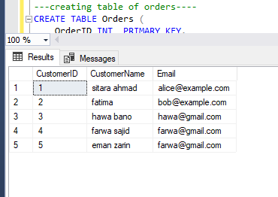

**ORDER TABLE:**

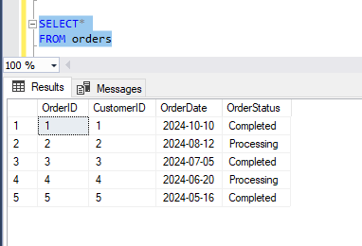

**AFTER UPDATE:**

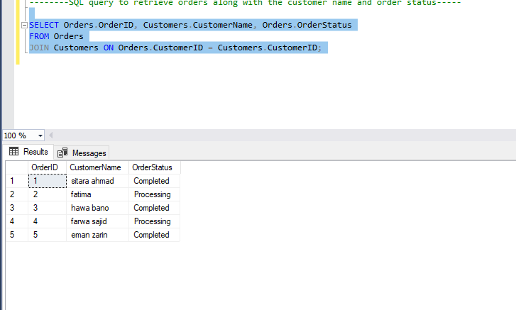

**TASK#2**

Write a SQL query to retrieve products along with their corresponding categories.

**SOLUTION:**

**BOOKS TABLE:**

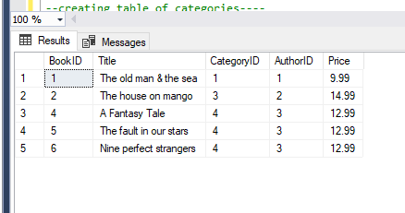

**CATEGORY TABLE:**

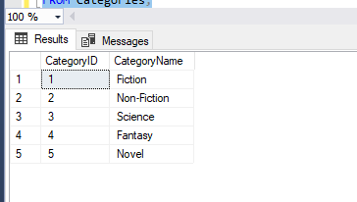

**AFTER UPDATE:**

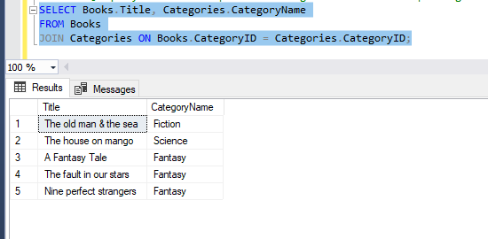

**TASK#3**

Write a SQL query to retrieve orders along with the product details (name, quantity, unit price).

**SOLUTION:**

**ORDER TABLE:**



**BOOKS TABLE:**



**ORDERDETAILS TABLE:**

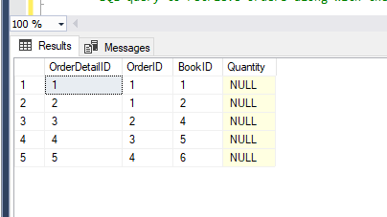

**AFTER UPDATE:**

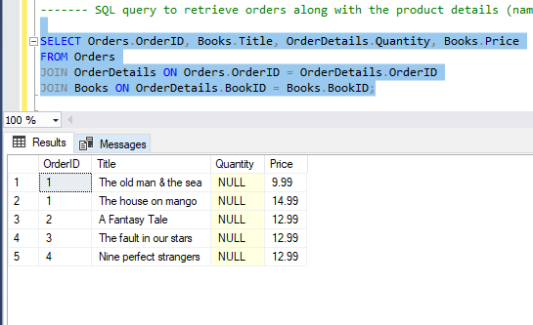

**TASK#4:**

Write a SQL query to retrieve customers who have placed orders.

**SOLUTION:**

**ORDER TABLE:**



**CUSTOMER TABLE:**



**AFTER UPDATE:**

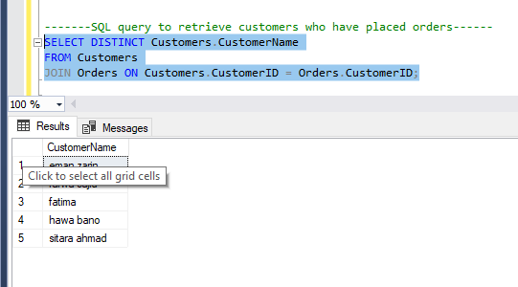

**TASK#5**

Write a SQL query to retrieve supplier information for each product.

**SOLUTION:**

**AUTHORS TABLE:**

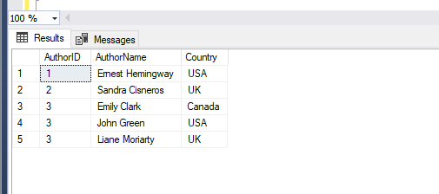

**BOOKS TABLE:**



**AFTER UPDATE:**



